1. Which plant generation is haploid?
a. sporophyte
*b. gametophyte

2. Spores are
*a. haploid
b. diploid
c. partly haploid and partly diploid

3. Gametes are
*a. haploid
b. diploid
c. partly haploid and partly diploid

4. Mosses have vascular tissue.
a. true
*b. false

5. When you look at a "typical" green moss plant, you are looking at the
a. sporophyte generation
*b. gametophyte generation

6. In mosses, how do sperm reach the eggs?
*a. They swim.
b. They are carried in pollen.
c. They are carried in fruit.

7. How do mosses disperse to new habitats?
a. By swimming
*b. By spores
c. By seeds

8. Plant spores are formed by
a. mitosis
*b. meiosis
c. both mitosis and meiosis

9. Moss gametes are formed by
*a. mitosis
b. meiosis
c. both mitosis and meiosis
10. On the diagram of the moss plant below, the structure labeled "a" is the
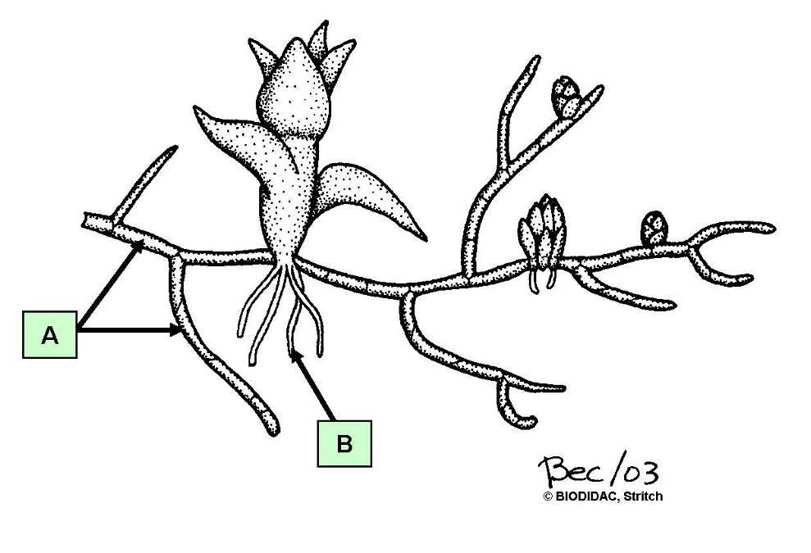

a. calyptra
*b. protonema
c. rhizoid
d. seta
e. spore

11. On the diagram of the moss plant below, the structure labeled "b" is the

a. calyptra
b. protonema
*c. rhizoid
d. seta
e. spore

12. On the moss plant diagram below, the structure labeled “a” is the
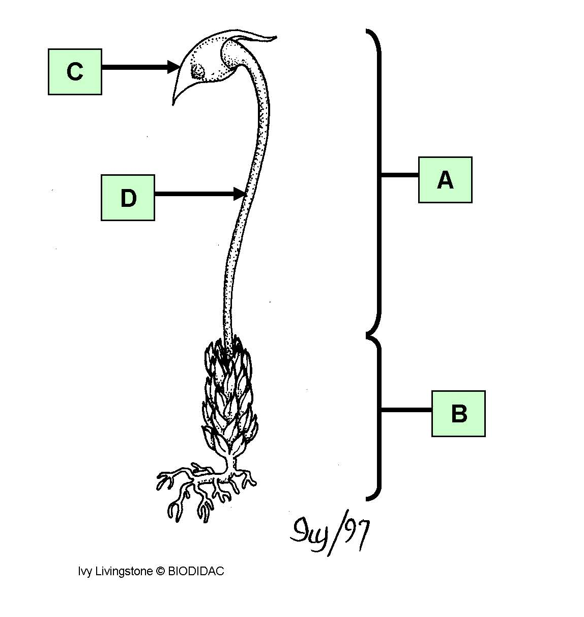
a. calyptra
b. female gametophyte
c. male gametophyte
d. seta
*e. sporophyte

13. On the moss plant diagram below, the structure labeled “b” is the
a. calyptra
*b. female gametophyte
c. male gametophyte
d. seta
e. sporophyte

14. On the moss plant diagram below, the structure labeled “c” is the
*a. calyptra
b. female gametophyte
c. male gametophyte
d. seta
e. sporophyte

15. On the moss plant diagram below, the structure labeled “d” is the
a. calyptra
b. female gametophyte
c. male gametophyte
*d. seta
e. sporophyte

16. On the moss plant diagram below, the structure labeled “a” is the
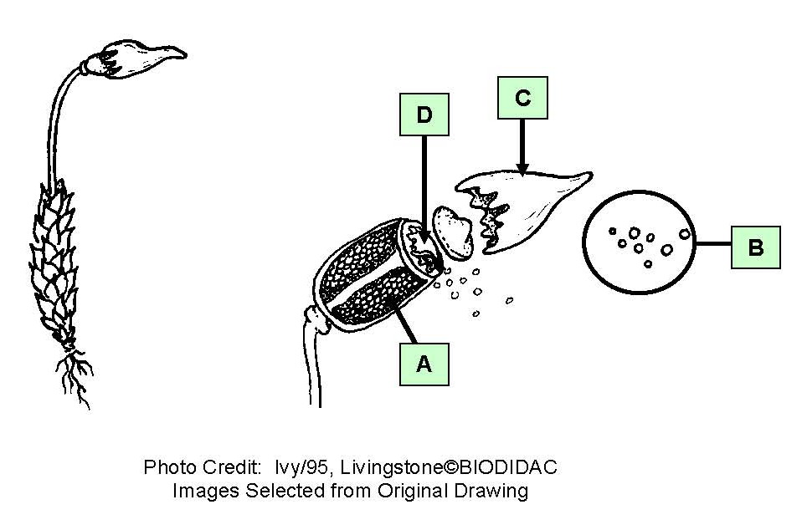

a. calyptra
*b. capsule
c. peristome
d. spores

17. On the moss plant diagram below, the structure labeled “b” is the

a. calyptra
b. capsule
c. peristome
*d. spores

18. On the moss plant diagram below, the structure labeled “c” is the

*a. calyptra
b. capsule
c. peristome
d. spores

19. On the moss plant diagram below, the structure labeled “d” is the

a. calyptra
b. capsule
*c. peristome
d. spores

20. On the moss plant diagram below, the structure labeled “a” is the
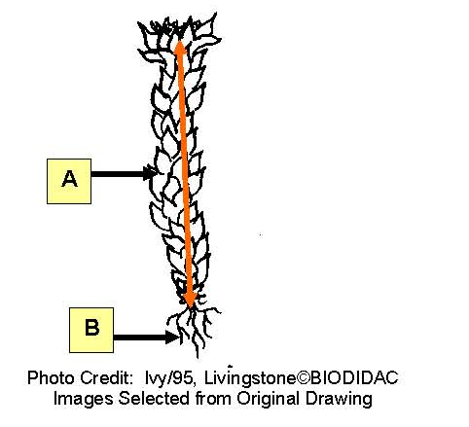

a. axis
*b. phyllid
c. rhizoids
d. roots

21. On the moss plant diagram below, the structure labeled “b” is the

a. axis
b. phyllid
*c. rhizoids
d. roots

22. On the moss plant diagram below, what does the orange line represent?

*a. axis
b. phyllid
c. rhizoids
d. roots

23. On the diagram of moss reproductive structures below, the structure labeled “a”
is the
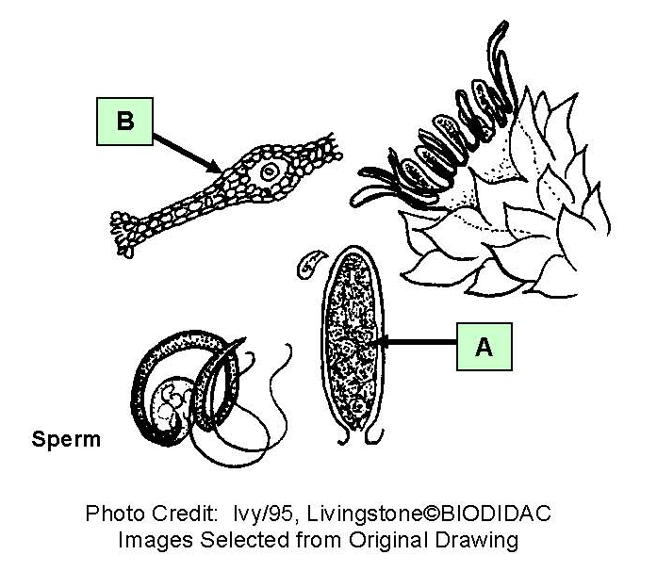

*a. antheridium
b. archegonium

24. On the diagram of moss reproductive structures below, the structure labeled “b”
is the

a. antheridium
*b. archegonium

